**TOM-AND-JERRY-EMOTION-DETECTION**

**USING CNN :**

Implemented the problem using CNN. CNN is the most popular neural network model being used for image classification.

So tried to obtain the best parameters by hypertuning the parameters i.e. Changing the number of layers, activation functions, filter sizes, max poolings, using dropouts, etc.

***No of Hidden Layers vs accuracy_score*** :

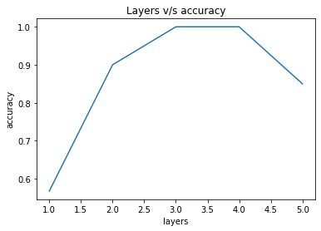

***No of Hidden Layers vs F1_score :***

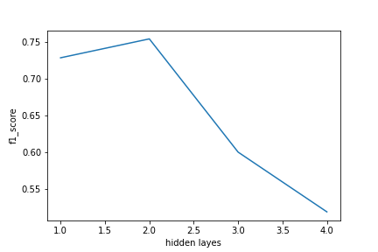

While trying different values of hidden layers, epoch was kept constant.

From the above observation, we can say that 3 hidden layers provides best accuracy.

***No of epochs vs Accuracy_score*** :

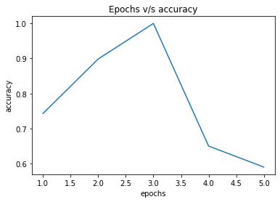

**Classification report:-**

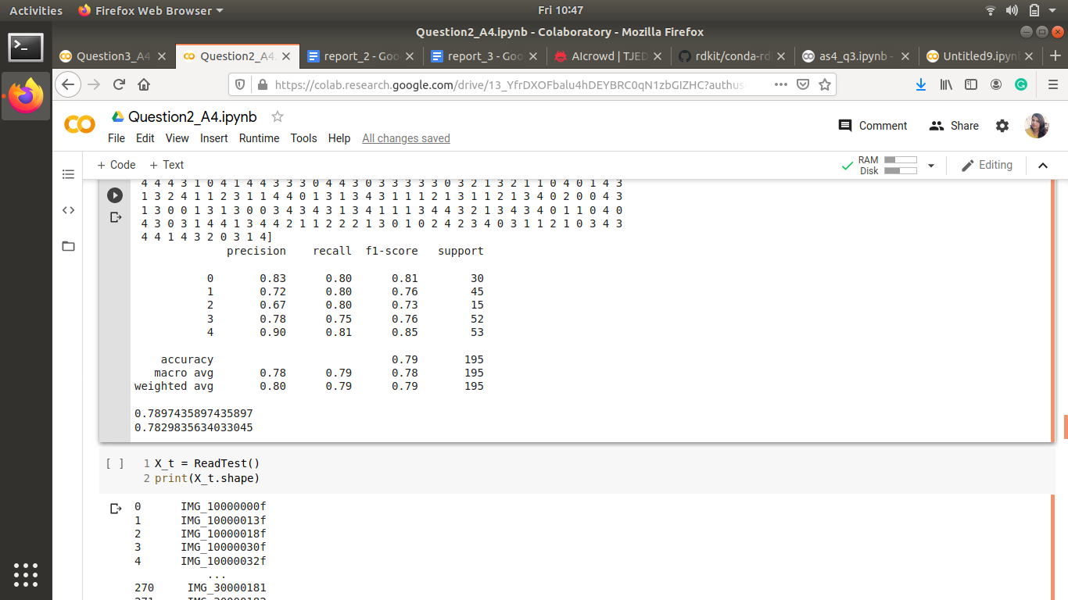

**Observation**:

The model that produced an accuracy of 100% is:

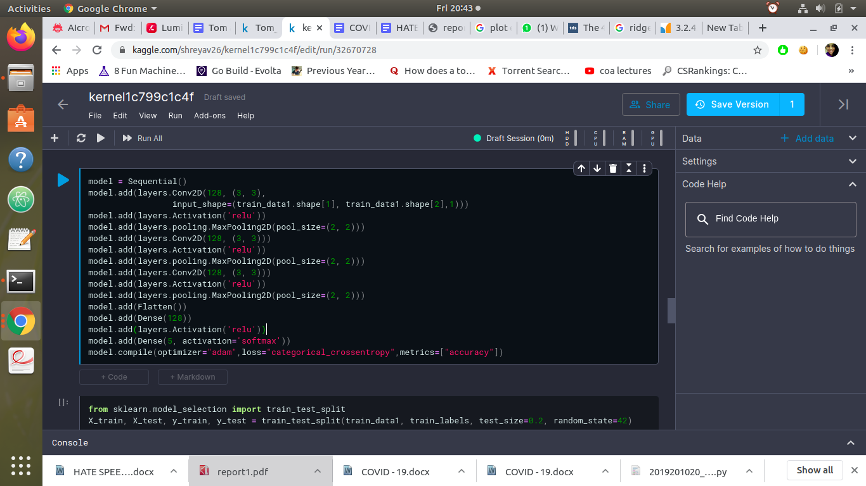

The optimizer used was **Adam Optimizer** with its default arguments.

**How to run the program:**

The paths are specified in the program itself. Those are absolute paths. So if one needs to run the program, he/she needs to change the paths in the program manually

And then run the program as a normal python file.